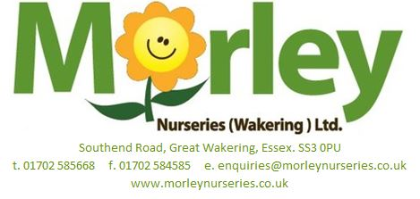
GENERAL EMPLOYMENT APPLICATION FORM
Please ensure that you fill out ALL the fields below

PERSONAL DETAILS
Surname (Mr/Mrs/Miss/Ms/Other):
Forename(s):
Current Address:
Postcode:
Email Address:
Contact Number:
Alternative Contact Number:
Date of Birth:
National Insurance Number:
YOUR APPLICATION
Position sought:
How did you hear about this vacancy?
Please give details of salary range required for a 40 hour week over 7 days:
EDUCATION DETAILS
Name of School/College |  | Date Range |  |  | Month/Year of Examinations |  |  | Subject ‘level’ and Grade
Please give details of any certificates, short courses, evening classes or any other training you have undertaken that you think may be relevant to working at Morley Nurseries.
(e.g. Forklift license plant knowledge, food Health and Hygiene certificates, coffee making, baking, till and cash handling experience)

EMPLOYMENT HISTORY
Please start with the most recent
Name/Address of Company | Position held/ Responsibilities |  |  | Date Range |  |  | Salary |  | Reason for Leaving
 |  |  |  |  |  |  | £
 |  |  |  |  |  |  | £
 |  |  |  |  |  |  | £
What is your current notice period?
Please give details of any breaks in your employment:
How many days sickness have you had in the past 2 years?
Please give the names and contact details of 2 referees, preferably your present employer or course tutor: |  |  | Referee 1:
 |  |  | Referee 2:
OTHER INFORMATION
Do you have a current driving license?
If yes, do you have any endorsements? (If so, please specify)
Are you legally able to work in the UK?
What is your ethnic origin?
Have you ever been convicted of any criminal offence which is not a ‘spent’ conviction? (If yes, please specify)
Do you consider yourself to have a disability? If so, do you require any modifications of equipment or areas in the work place before an interview?
Do you have any conditions that may affect your ability to carry out manual handling tasks? (If yes, please specify)
If asked, will you agree to a medical examination?
Please give details of any hobbies, interests and pastimes and any responsibilities or offices held:
SSUPPORTING INFORMATION
Please provide information in support of your application. This should include relevant experience and training as to why you feel you should be considered for this post:

DECLARTION
MORLEY NUSREIES IS AN EQUAL OPPORTUNIES EMPLOYER

To the best of my knowledge and belief, the information I have given is both true and correct in every respect. I understand that withholding or mis-stating any facts which may be relevant to my employment, can result in the refusal or termination of employment

Signature (PRINT FULL NAME)  ________________________________________________ |  |  |  |  |  | Date of Application (DD/MM/YY)  ________________________________________________
Please note that information from this application may be processed for the purposes registered by the company under the Data Protection Act 1998. Individuals have the right of access to personal data concerning them. You hereby consent to the company recording data and disclosing information contained in this application form to third parties, as appropriate.

Once you are happy with your application, please send your form and CV directly to our HR department via email at: hr@morleynurseries.co.uk
If you have any questions in the meantime, please do not hesitate to contact us at either: hr@morleynurseries.co.uk or 01702 585668.

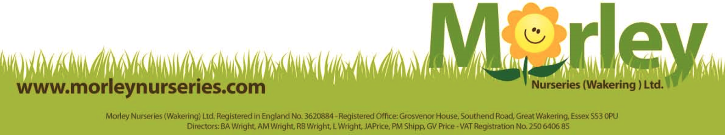
GOOD LUCK!

